**Early recruitment of muscle activity during delayed reach movements is correlated with reaction times and based on task context**

(Supplementary figures and legends)

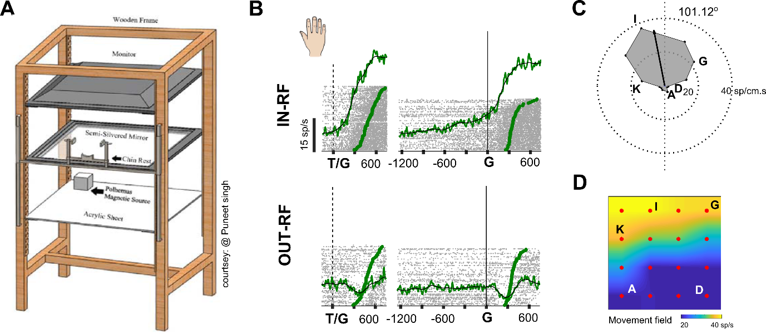

**S1: EMG signals and hand movements.**

A) Schematic representation showing the experimental setup used for carrying out the task.

B) Top panel. Response of deltoid (shoulder) muscles when target was located towards the movement field for immediate and delayed movements. Bottom panel. Response of deltoid (shoulder) muscles when target was located away from the movement field.

C) A polar plot showing the preferred movement direction.

D) A The movement field is colour coded with yellow indicating high activity and blue indicating lower activity.

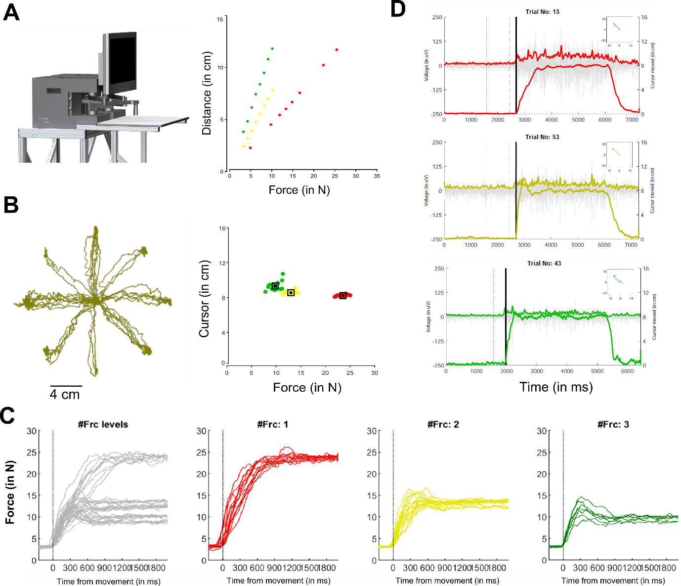

**S2: Cursor movements and raw emg signal captured for different force levels.**

A) Left panel. Schematic representation showing the experimental setup used for carrying out the task. Right panel. Scatter plot showing distance moved by cursor on screen as a function of different force levels applied on the manipulandum of the robotic arm.

B) Left panel. Shows the spatial trajectory of cursor movements to eight different target locations on screen. Right panel. The distance moved by the cursor from centre of fixation spot at the end of each trial for each force condition.

C) First panel. Force profile for each trial (grey trace) as a function of time, aligned on movement onset. Second panel (red), third panel (yellow) and fourth panel (green) showing example trials for each force level, respectively.

D) Root mean square (rms) response variation in strength of the emg signal for each example trial as a function of different force levels (red, yellow and green).

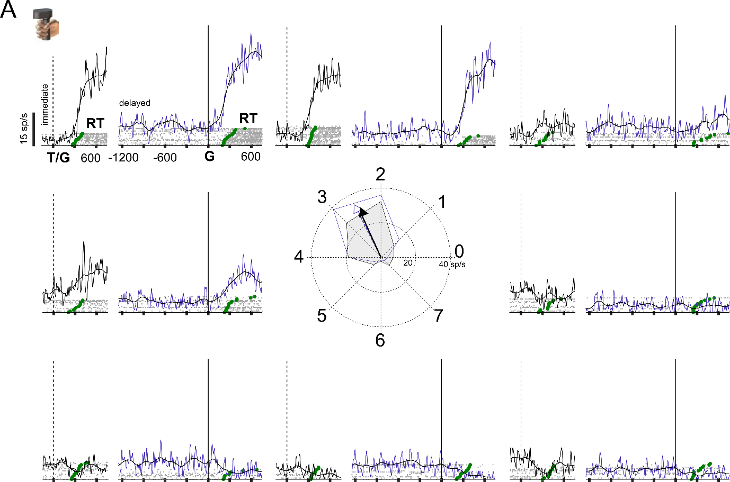

**S3: Showing spatially tuned response field for cursor-based movements**

A) EMG responses for immediate (black) and delayed (blue) movements, aligned on the go cue, for eight different target locations, for a representative session recorded from the shoulder muscles during cursor-based movements. Each grey marker represents a spike. Each spike train represents the response on a single trial which were sorted based on reaction time (green markers). Solid line for the immediate (black) and delayed (blue) task, represents the trend seen in the muscle activity for the example session.

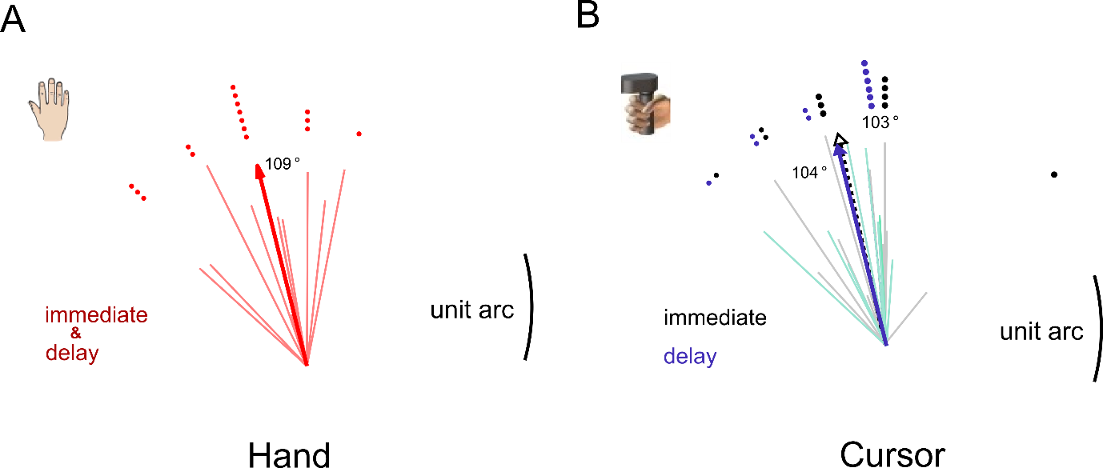

**S4: Preferred directions for hand and cursor movements.**

A) The plot shows the preferred direction (red) for the population (thick line) and each session (thin lines) that was recorded prior to immediate and delayed hand movements for each subject.

B) The plot shows the preferred direction for the population (thick and dashed line) and each session (thin lines) for immediate (grey) and delayed (blue) cursor movements, respectively.